Chapter 2: Rocks and minerals

2.1 Rocks have different properties

Literacy support worksheet answers (pages 18–19)

Rock properties

1 Match the rock to its correct properties:

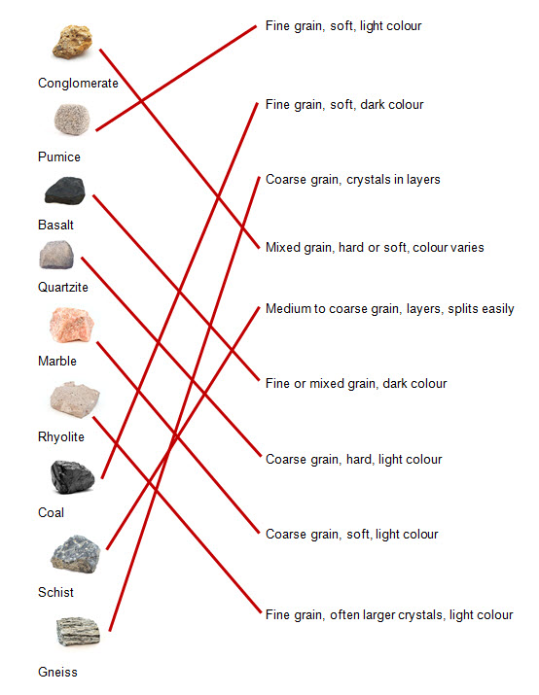

2 What does the word ‘density’ mean?

Density is the heaviness or weight of the rock.

3 Why are rocks different colours?

The chemicals that the rocks are made up of mean they are different colours.

4 How can you identify rocks? Use an example.

You can identify rocks first by how they look. For example, coal is black or dark brown.

5 List three ways crystals are different to grains.

a Crystalsare small pieces of organised particles that have smooth sides and sharp edges.

b Crystals are one colour and reflect light off flat surfaces.

c Grains are small pieces of material, sometimes microscopic, which are dull and differently coloured.

6 Who am I? Use table 2.1 and figure 2.6 to name the following rocks:

a I am dark in colour. I am soft and have a fine grain size. Some say I look like black glass.

Obsidian

b I have a course grain. I am soft and light in colour. Sometimes I look pink and other times I look white.

Marble

c I am fine-grained, have larger crystals and am light in colour. I am also very hard, with approximately one and a half times the density of water.

Ryolite

Word detective

7 Matching meaning

Match the words (on the left) with the correct descriptions (on the right).

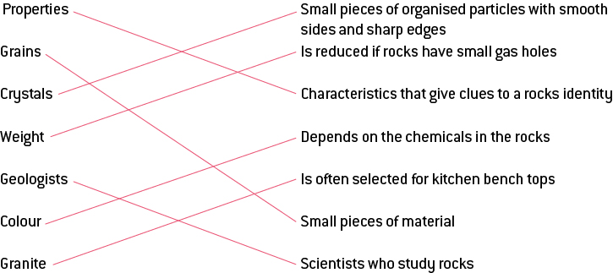

2.2 Rocks are made up of minerals

Literacy support worksheet answers (pages 20–21)

Classifying minerals

1 What is a mineral?

A mineral is a naturally occurring solid substance with its own chemical composition, structure and properties.

2 How are minerals found?

Minerals are found as crystals.

3 If graphite and carbon are both made of pure carbon, why do they look different?

They look different as their atoms are arranged differently.

4 There are six characteristics that can be used to classify rocks. Briefly, in only a few words, explain each one.

a Colour: the colours that make up the rock

b Lustre: shine

c Transparency: how much light can pass through

d Composition: what it is made of

e Hardness: how easily it can be scratched

f Cleavage: how rocks look when they break after being hit

5 What is the Mohs scale?

It is a scale of the hardness of a rock, 1 = soft, 10 = hard

6 Explain how Mohs knew that diamond was harder than talc.

Diamond can scratch talc.

7 What are the three cleavage planes?

a Left and right

b Front and back

c Top and bottom

8 Create a dichotomous key to identify the seven rocks below using the properties of rocks and minerals on pages 18–21. It has been started for you.

|  |  |  |  |  |  |  |
| --- | --- | --- | --- | --- | --- | --- |
|  |  |  |  |  |  |  |
| Diamond | Quartz | Apatite | Amber | Fluorite | Pyrite | Sulfur |

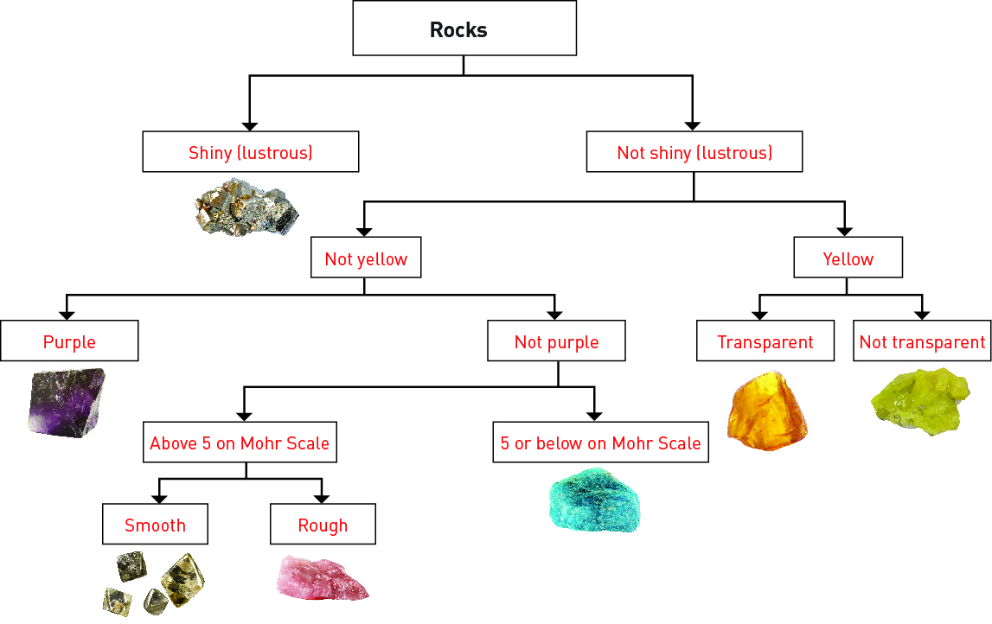Word detective

9 Boggle

Find and circle as many words as you can about classifying minerals in the puzzle below. The words can run up and down or left to right as well.

Student responses will vary.

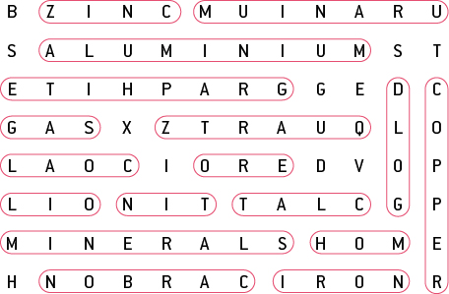

2.3 Minerals are a valuable resource

Literacy support worksheet answers (pages 22–23)

Minerals as resources

1 What is an ore?

An ore is a mineral that contains a large amount of useful metal.

2 When and where was gold first discovered in Australia?

Gold was first discovered in Australia in the 1850s in Bathurst, New South Wales.

3 Gold has always been a resource in demand. Name four uses for gold:

a Jewellery

b Electronics

c Fillings for teeth

d To protect satellites and space craft from solar radiation

4 Australia is one of the world’s biggest producers of aluminium. Take-away food is often served in aluminium containers. What are three properties of aluminium that make it useful?

a It can be heated to keep food warm.

b It is flexible.

c It is light and easy to use.

5 Why is it important to recycle aluminium?

It is important to recycle aluminium as recycling only uses 5% of the energy needed to produce it from bauxite. It also saves us from using coal and producing greenhouse gases.

6 Which minerals are found in mobile phones?

Niobium and tantalum are found in mobile phones.

7 How does recycling the minerals in mobile phones help the ecosystem in the Congo?

Recycling the minerals in mobile phones helps reduce the impact of mining on the ecosystem.

8 What form is copper in when it is mined in Australia?

Chalcopyrite

9 Name three uses for copper:

a Electrical generators and motors

b Televisions

c Water pipes

Word detective

10 True or false

Read the statement and circle whether it is true or false.

a Minerals are renewable resources.

F

b Australia is rich in mineral resources.

T

c Copper was the first metal to be used by humans.

T

d The minerals in mobile phones cannot be recycled.

F

e Mining in the Congo is threatening gorilla habitats.

T

f Silica mined from sand is found in toothpaste.

T

g Mineral sands are old beach sands.

T

h Minerals are in high demand in China.

T

i Granite is found in toothpaste.

F

j Recycling aluminium leads to reduced greenhouse gases.

T

k Copper is used as fillings for teeth.

F

l The demand in copper is predicted to rise.

T

m Gold was discovered in Australia in the 1820s.

F

2.4 Igneous rocks develop from magma and lava

Literacy support worksheet answers (pages 24–25)

Igneous rocks

1 What does the term ‘igneous’ mean?

The term ‘igneous’ comes from the Latin word *ignis,* which means ‘fire’.

2 What material is used to form an igneous rock?

Lava is used to form an igneous rock.

3 Circle the correct answer. Lava forms:

On the surface of the Earth as extrusive Igneous rock.

4 Complete the following table to summarise the main differences between the formation of extrusive and intrusive igneous rock.

|  |  |  |
| --- | --- | --- |
|  | **Extrusive igneous rock** | **Intrusive igneous rock** |
| **Formed by lava or magma?** | Lava | Magma |
| **Formed inside or ouside of the volcano?** | Outside | Inside |
| **Method of cooling**  **(quick or slow)?** | Quickly | Slowly |
| **How does it reach the surface of the Earth?** | It is already on the surface | Pushed to the surface or erosion |

5 What is the most common type of rock in the Earth’s crust?

Basalt is the most common type of rock in the Earth’s crust.

6 Label the following diagram of a volcano:

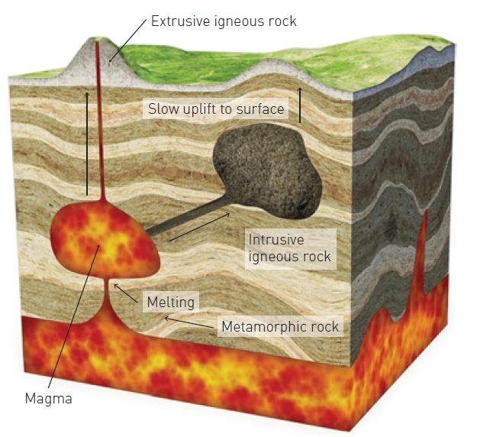

Word detective

7 Mumbo jumbo

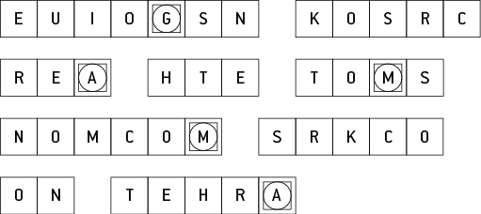

Message: Igneous rocks are the most common rocks on Earth.

Secret word: Magma.

2.5 Sedimentary rocks are compacted sediments

Literacy support worksheet answers (pages 26–27)

Sedimentary rocks

1 How are sedimentary rocks formed?

When particles of eroded rocks are compressed into layers over a long time

2 What are sediments? Give an example.

Particles of rock which erode, and are then transported and deposited by water and wind. E.g. sand

3 Explain the formation of sedimentary rock by placing the following sentences in order to match the diagrams:. Write ‘a’, ‘b’, ‘c’ or ‘d’ from the sentences below, beside the corresponding rock diagram.

a Chemicals that are dissolved in the water can soak into the sediments.

b Sediments are deposited in layers.

c The chemicals help cement the grains together once the water has evaporated.

d The grains of sediment in lower layers begin to squash together.

|  |  |
| --- | --- |
|  | b Sediments are deposited in layers. |
|  | d The grains of sediment in lower layers begin to squash together. |
|  | a Chemicals that are dissolved in the water can soak into the sediments. |
|  | c The chemicals help cement the grains together once the water has evaporated. |

4 Complete the following list. Sedimentary rock can be formed from:

a Sediments of non-living things

b Remains of plants

c Remains of animals

d Remains of other living things or organisms

Word detective

5 Draw and label

Draw and label a diagram of how stalagmites and stalactites are formed using the following words:

dissolved limestone drips deposited stalagmite stalactite

Student drawings will vary.

2.6 Metamorphic rocks require heat and pressure

Literacy support worksheet answers (pages 28–29)

Metamorphic rocks

1 How is metamorphic rock formed?

When igneous, sedimentary or older metamorphic rocks are changed by intense heat and pressure inside the Earth.

2 What does metamorphosis mean?

It means ‘change in form’.

3 Why are metamorphic rocks so strong?

They are strong because they are subjected to heat and pressure.

4 Research and label the following diagram of the rock cycle:

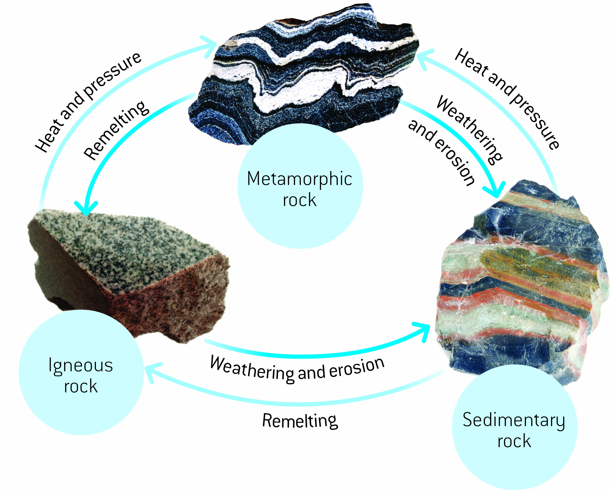

Word detective

5 Crossword

Read the clues and complete the crossword below.

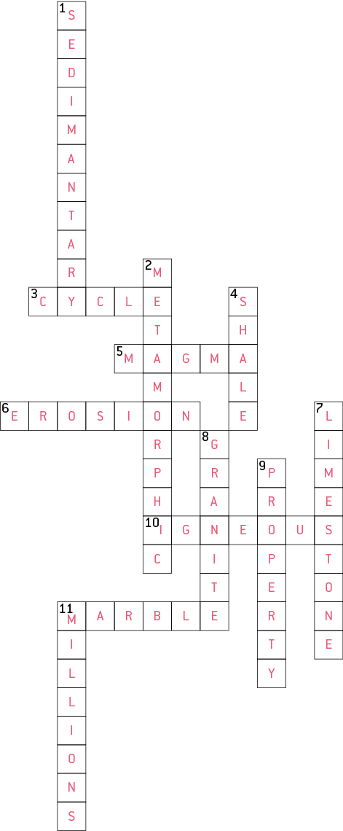

2.7 The rock cycle causes rocks to be re-formed

Literacy support worksheet answers (pages 30–31)

The rock cycle

1 What is weathering?

The breaking down of rocks and minerals through the movement of water and animals, and the extremes of temperature is called ‘weathering’.

2 What is erosion?

The movement of the sediment to another area is called ‘erosion’.

3 What is onion-skin weathering?

Onion-skin weathering is when the outside of a rock peels off.

4 Use the sentences below to fill in the gaps of the cycle that describe frost shattering.

• Water expands and pushes against crack in the rock

• Ice melts and water fills the crack again

• Water freezes in the crack of rock at night

• Crack becomes larger

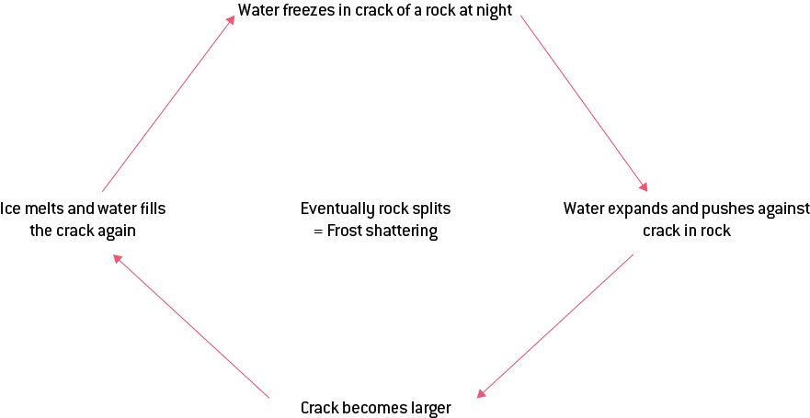

Word detective

5 Order us!

Put the sentences below in the correct order within the cartoon strip and illustrate.

• When the lava cools it hardens to become an igneous rock.

• The rock gets hotter and experiences more pressure as it gets deeper – it turns into a metamorphic rock.

• A rock is on the Earth’s surface.

• As the temperature keeps rising the rock becomes magma.

• Sediments form on top of the rock causing it to sink deeper. Magma will flow to a volcano where it will become lava as

• it exits the volcano.

|  |  |
| --- | --- |
| A rock is on the Earth’s surface. | Sediments form on top of the rock causing it to sink deeper. |
| The rock gets hotter and experiences more pressure as it gets deeper – it turns into a metamorphic rock. | As temp keeps rising the rock becomes magma. |
| Magma will flow to a volcano where it will become lava as it exits the volcano. | When the lava cools it hardens to become an igneous rock. |

2.8 Science as a human endeavour: Weathering and erosion can be prevented

Literacy support worksheet answers (pages 32–33)

Weathering and erosion

1 What is the role of a soil erosion engineer?

Erosion engineers prevent or slow down the rate of soil/rock erosion.

2 The picture shows the result of a sequence of events.

Write the events below in order to show how the above could have happened:

Soil under cliff falls; Population increase; Topsoil erodes; Less trees to hold soil together; More houses built.

a Population increase

b More houses built

c Less tress to hold soil together

d Topsoil erodes

e Soil under cliff falls

3 Match the following engineering solution to the erosion problem.

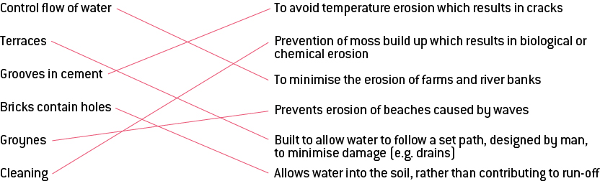

Word detective

4 Word search

Find the words listed, in the puzzle below.

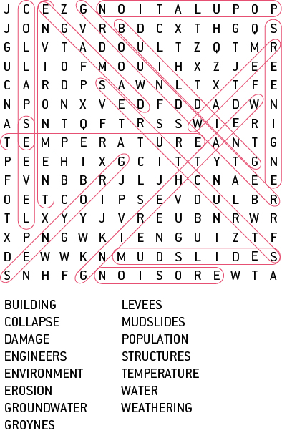

2.9 Science as a human endeavour: Rocks are studied by geologists

Literacy support worksheet answers (pages 34–35)

The work of geologists

1 How old is the Earth?

The Earth is 4.5 billion years old.

2 What is a fossil?

The remains (or imprints) of animals or plants preserved in rock are called ‘fossils’.

3 What kind of rocks are fossils found in?

Sedimentary rocks

4 How many years does it take to uncover a fossil?

Millions of years

5 When an organism is going to be fossilised, what can it be caught in?

a Mud

b Silt

6 What is working out whether rocks are younger or older called?

Comparative dating

7 Draw a line to match the pictures with the descriptions below:

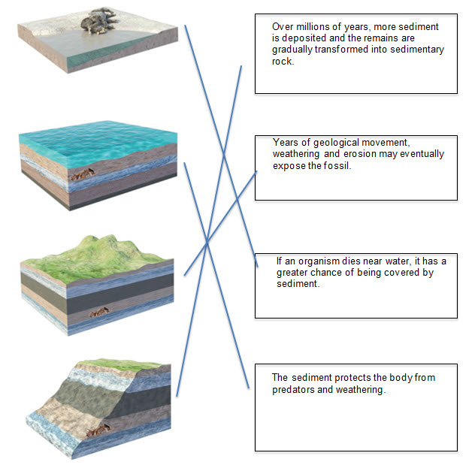

8 Fill in the gaps using the words below:

mammals younger fish simple shells

Extremely old rocks contain fossils of simple animals, whereas slightly younger rocks have fossils of animals with shells. Rocks that are younger still have fossils of fish. Only the newest rocks have fossils of mammals.

Word detective

9 Draw and label

Draw and label a diagram of comparative dating using the following words. Use figure 2.46 to help you.

shale limestone oldest rock conglomerate shale youngest rock

Student diagrams will vary.